**Syed Shabee Rahman // 100853015**

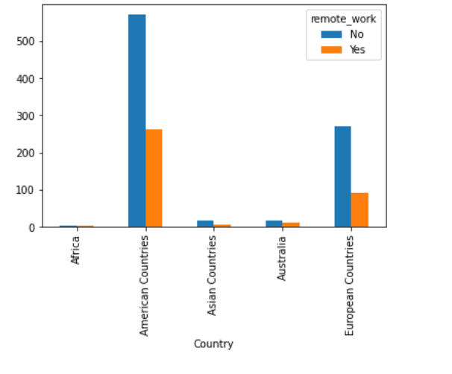

This analysis shows the continents and how many remote work options they offer to their residents. The Orange bar shows the number of remote work jobs of the people survey for the dataset and the Blue bars show the number of in-office jobs they offer.

We can clearly see the difference between the employment level of the continents as well here. The American and the European continents have much more jobs either way, remote or in office, than the other continents.

But, it can also be observed that the number of remote jobs are less in each continent than the number of in-office job.

Here, we can observe the attitude of the people towards mental illness and the consequences the age group go thorugh. We can say that the adult age group of 20 to 45faces a lot more instability as compared to the seniors age group of 45 to 100.